Course 4

Jenkin pipeline : Jenkin pipeline is type of Jenkin job which contains collection of event or jobs which are interlinked with one another in a sequence.

Jenkin pipeline job with Jenkins file with post task

<https://github.com/Kaleakash/Jenkins_post_pipe_line_job.git>

branch master

Create New spring boot project with simple rest api, then we push this project in our own repository inside this repository we write our own Jenkinsfile and we create Jenkin pipe line job to build the project.

1. Create separate folder and open the eclipse IDE inside that folder.
2. Then open spring initlizer web site and create simple spring boot with web starter by default testing starter.

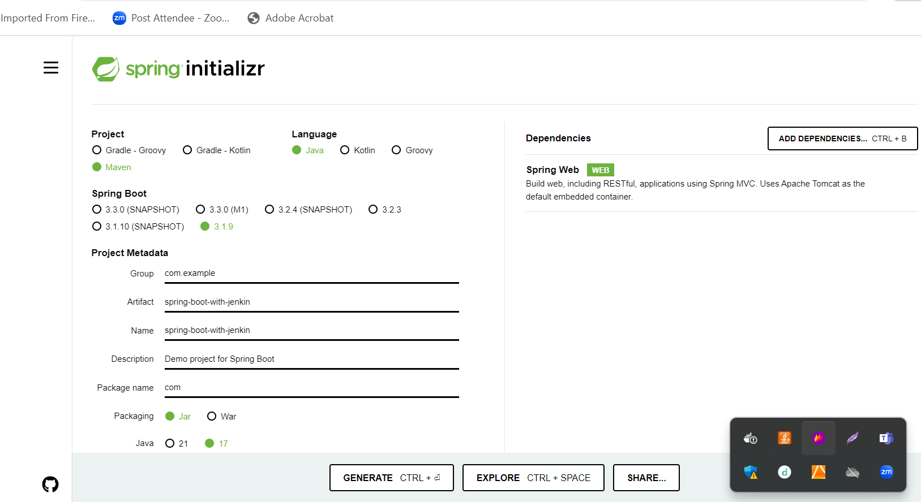

1. Extract the project and create simple rest api and import in eclipse IDE.
2. Create simple rest api and write simple junit test for that rest api
3. Then create Jenkinsfile which help to build the project
4. Now create remote repository in git hub account.

After created repository

git init

git commit -m "first commit"

git branch -M main

git remote add origin <https://token@github.com/Kaleakash/springmavenwithjenkin.git>

git push -u origin main

1. Now in local machine or virtual lab open the terminal or command prompt inside a project (in location pom.xml file present)

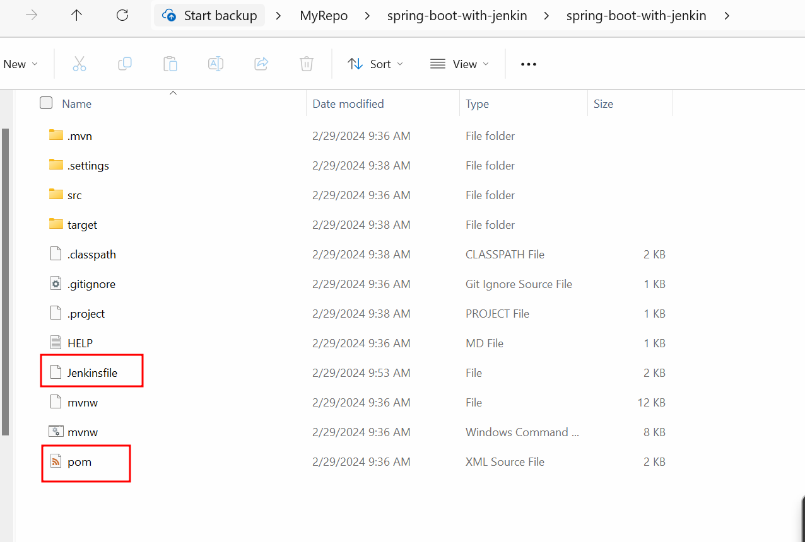

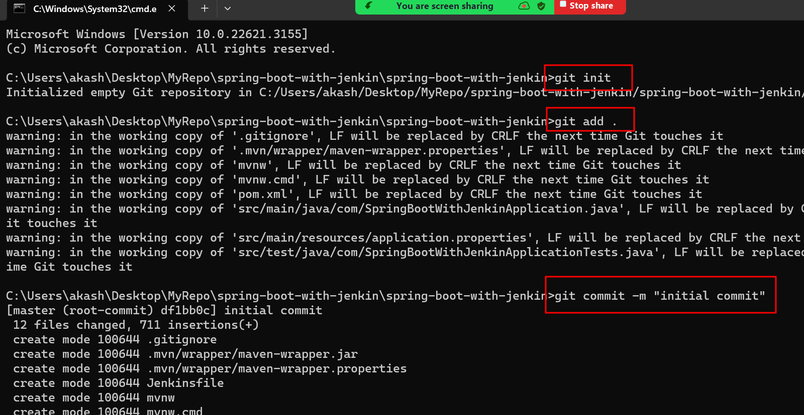

Now we need to create Jenkin pipeline job which is responsible to pull the project from github account and using Jenkinsfile run the jobs.

